Executive HR Insight Package
Q2 2026 regional workforce review — which region needs the most immediate HR follow-up?
Northwind Health Group · Prepared by People Analytics for the regional leadership team and the South regional leader · Reporting periods: Q1 2026 (baseline) and Q2 2026 (current) · All data synthetic — no real people · Companion files: Northwind_Workforce_Summary_Q2_2026.csv (submitted separately) and the written recommendation.
Executive summary
Headline finding. South needs the most immediate HR follow-up. Its voluntary attrition was 7.1% in Q2 2026, against 2.7% for the organization and 1.4–1.8% in every other region, and it was the only region to lose headcount (210 → 205).
Supporting evidence. South accounts for 15 of the organization’s 27 voluntary leavers (56%) from 21% of the starting headcount. Recruiting is not keeping pace: screened-to-interview conversion 55.6% (organization 70.5%), average time-to-fill 45 days (organization 35.7), and 18 of 36 requisitions filled. Escalations Ops backlog per FTE is 6.8, about double the other regions (3.2–3.6). South’s L3 compa-ratio (0.98) is the lowest, but nothing in the data shows it explains who left.
Business implication. South lost 17 people and added 12 in Q2, while half its requisitions are still open and its Escalations Ops team carries the heaviest backlog. The data show where the pressure sits, not why people left — so the reasons should be established before committing to costly fixes.
Next step. The South HR Business Partner leads a targeted 30-day review of South’s 15 Q2 voluntary leavers, sponsored by the South regional leader. Broader action, including any pay response, waits for its findings (Sections 9–10).
Narrative first drafted with Microsoft Copilot, then verified and revised — see Section 12.
1 Workforce Question and Business Context
Item | Detail
Leadership question | “Which region needs the most immediate HR follow-up this quarter, and what evidence-proportionate action should we recommend to the regional leader?”
Audience | Regional leadership team; the recommendation is addressed to the South regional leader.
Reporting periods | Q1 2026 = baseline (Q1-end headcount, supplied as Begin_HC / Begin_Population). Q2 2026 = current quarter for every measure.
Function under focus | Escalations Ops (Support division).
Business-context measure | Backlog per FTE — Q2 average, Escalations Ops only.
Populations in scope | Headcount, recruiting and attrition: all employees in each region. Compensation: Job Level L3 sample per region (n = 36–62). Backlog: Escalations Ops only.
Evidence used | Executive_HR_Insight_PowerBI_model.pbix, Project_prepared_workforce_workbook.xlsx, Workforce_planning_scenario.xlsx, Project_metric_definition_pack. Synthetic Northwind data only.
2 Metric-Definition Check
Metric | Approved definition (Metric Definition Pack) | What was verified
Q2 End Headcount | Distinct EmployeeID active on 30 Jun 2026. | Reconciles in all four regions (Q1 end + joiners + transfers in − leavers − transfers out). Employee IDs not supplied.
Headcount Change | Q2 End HC − Q1 End HC (Q1 End HC = Begin_HC). | Matches Region_Summary, the scenario table and PBIX [Headcount Change].
Screened-to-Interview Conversion (%) | Sum interviewed ÷ sum screened, per region, Q2. | Recomputed from counts; matches. Kept separate from requisition fill rate (filled ÷ open), Section 4.
Average Time-to-Fill (days) | Mean of (FillDate − OpenDate) for requisitions filled in Q2. | Regional means as supplied; requisition dates not provided.
Voluntary Attrition Rate (%) | Voluntary separations Q2 ÷ beginning-of-quarter population × 100 (Begin_Population, not an average of monthly snapshots). | Recomputed on Begin_Population (= Begin_HC in every region). Quarterly; never annualised.
Average Compa-Ratio | Mean of individual compa-ratios in the scope group, with its standard deviation. | Compared only within Region × L3; n and SD in Section 6.
Backlog per FTE | Q2 average backlog ÷ FTE, Escalations Ops only. | Function-level only; not linked to region-wide metrics.
Organization roll-up rule — computed from counts, never the mean of the four regional rates
Measure | Rule applied | Organization value | Mean of 4 regions (not used)
Q2 End Headcount | Sum of four regions | 1,007 | —
Headcount Change | Sum of four regions | +7 | —
Screened-to-Interview Conversion | Total interviewed ÷ total screened = 335 ÷ 475 | 70.5% | 71.0%
Average Time-to-Fill | Weighted by requisitions filled (67 filled) | 35.7 days | 35.3 days
Voluntary Attrition Rate | Total voluntary separations ÷ total Begin_Population = 27 ÷ 1,000 | 2.7% | 3.0%
Average Compa-Ratio (L3) | Weighted by N_L3_Sample (n = 186) | 1.00 (pooled SD 0.06) | 1.00
Backlog per FTE | Unweighted mean of four regions — FTE counts not supplied | 4.25 (unweighted mean, not a true organization rate) | same
Traceability notes
- Sources. Every figure comes from Project_prepared_workforce_workbook.xlsx (sheet named under each exhibit); the Power BI model holds identical tables, and the four regional rows match Workforce_planning_scenario.xlsx. 28 of 28 reconciliation checks passed (movement identity, rate recomputation, cross-sheet agreement).
- Dashboard evidence. Exhibits 3–6 are recreated in Python from the model’s tables using the same logic as its DAX measures ([Q2 End Headcount], [Headcount Change], [Screened-to-Interview %], [Avg Time-to-Fill (days)], [Voluntary Attrition %], [Avg Compa-Ratio], [Backlog per FTE (unweighted mean)]). They are not screenshots of the .pbix.
- Refinements to the prepared report. Titles state metric, period and population; each rate chart carries an organization reference line computed from counts; South is highlighted and other regions shown in grey; compa-ratio is shown with its L3 control, n and SD; conversion is shown apart from fill rate. The prepared attrition-vs-backlog scatter was not used: four points invite a causal reading.
- Rounding. Rates to one decimal place; organization values computed from unrounded counts.
3 Headcount and Movement Evidence
Exhibit 3. Point-in-time headcount and change, Q1 2026 end → Q2 2026 end, by region
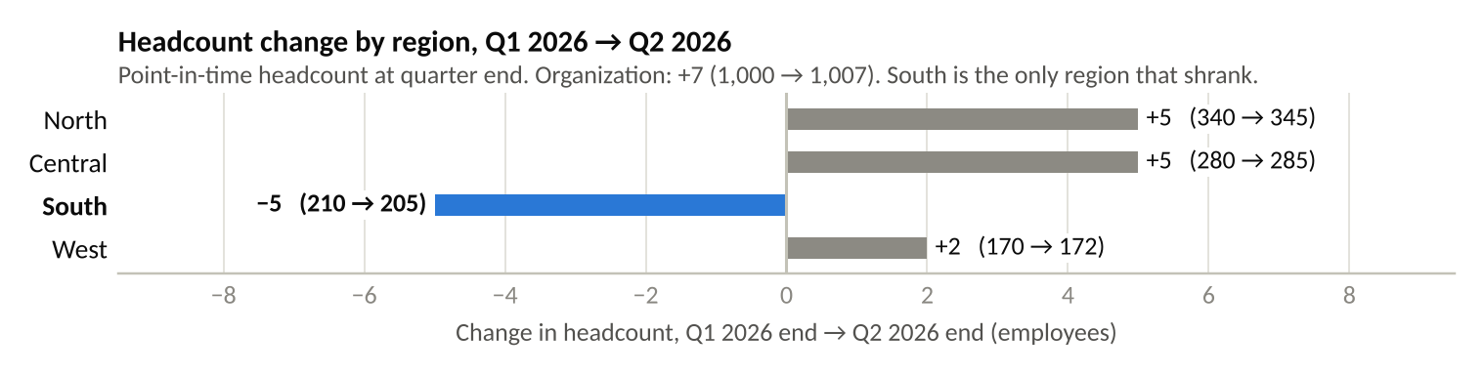
Source: Workforce_Movement (Begin_HC, End_HC); PBIX measures [Q2 End Headcount], [Headcount Change]. Population: all employees, whole region.
Region | Q1 2026 end headcount | Joiners | Transfers in | Voluntary leavers | Involuntary leavers | Transfers out | Q2 2026 end headcount | Change
North | 340 | 11 | 2 | 5 | 2 | 1 | 345 | +5
Central | 280 | 10 | 1 | 4 | 1 | 1 | 285 | +5
South | 210 | 11 | 1 | 15 | 2 | 0 | 205 | −5
West | 170 | 5 | 1 | 3 | 1 | 0 | 172 | +2
Organization | 1,000 | 37 | 5 | 27 | 6 | 2 | 1,007 | +7
Reading. South is the only region where people leaving (17: 15 voluntary, 2 involuntary) outnumbered people arriving (12: 11 joiners, 1 transfer in). The other three regions grew by 2 to 5 each.
4 Recruiting Evidence
Exhibit 4. Screened-to-interview conversion and average time-to-fill by region, Q2 2026
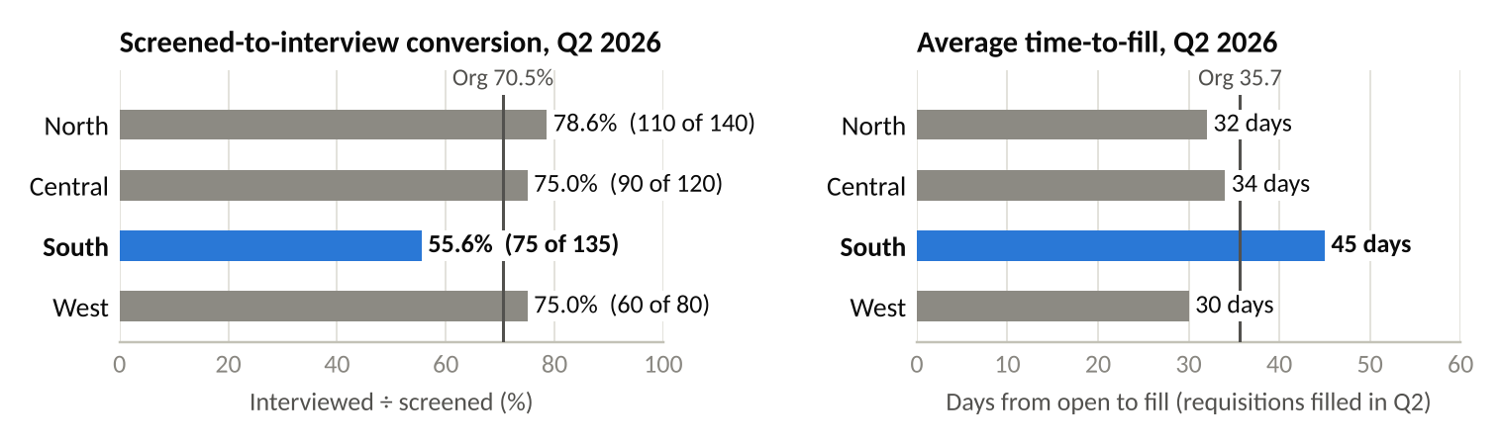
Source: Recruiting_Summary; PBIX measures [Screened-to-Interview %] (interviewed ÷ screened) and [Avg Time-to-Fill (days)] (organization weighted by requisitions filled). Population: all requisitions and candidates in Q2.
Region | Requisitions open | Requisitions filled | Requisition fill rate (filled ÷ open) | Candidates screened | Candidates interviewed | Screened-to-interview conversion (interviewed ÷ screened) | Avg time-to-fill (days)
North | 28 | 21 | 75.0% | 140 | 110 | 78.6% | 32
Central | 24 | 17 | 70.8% | 120 | 90 | 75.0% | 34
South | 36 | 18 | 50.0% | 135 | 75 | 55.6% | 45
West | 16 | 11 | 68.8% | 80 | 60 | 75.0% | 30
Organization | 104 | 67 | 64.4% | 475 | 335 | 70.5% | 35.7
Reading. Conversion and fill rate are different measures: conversion tracks the candidate funnel; fill rate tracks requisitions closed. South is lowest on both (55.6% and 50.0%), carries the most open requisitions (36, with 18 unfilled) and takes longest to fill (45 days vs 35.7).
5 Attrition Evidence
Exhibit 5. Voluntary attrition rate on the approved denominator, and how concentrated it is, Q2 2026
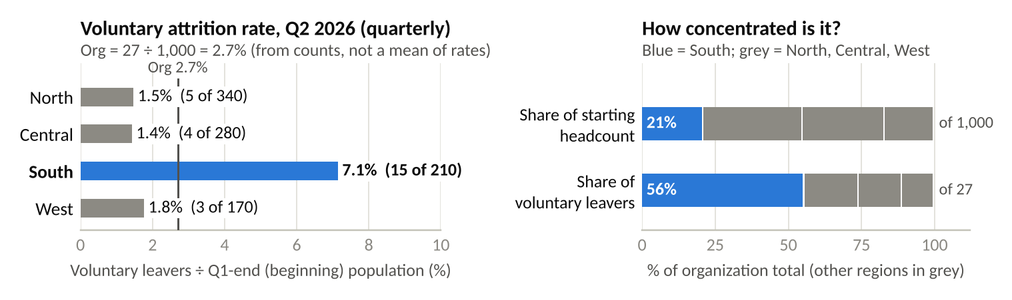
Source: Attrition_Summary (Begin_Population, Voluntary_Sep); PBIX measure [Voluntary Attrition %] = voluntary separations ÷ beginning-of-quarter population. Population: all employees, whole region.
Region | Beginning-of-quarter population (Q1 end) | Voluntary separations, Q2 | Voluntary attrition rate (quarterly) | Share of starting headcount | Share of voluntary leavers
North | 340 | 5 | 1.5% | 34.0% | 18.5%
Central | 280 | 4 | 1.4% | 28.0% | 14.8%
South | 210 | 15 | 7.1% | 21.0% | 55.6%
West | 170 | 3 | 1.8% | 17.0% | 11.1%
Organization | 1,000 | 27 | 2.7% | 100.0% | 100.0%
Reading. The elevated pattern is concentrated, not broad: South’s rate is 7.1%, while North, Central and West sit at 1.4–1.8%, all below the organization rate of 2.7%. South holds 21% of the starting headcount but 56% of voluntary leavers.
6 Compensation Evidence
Exhibit 6. Average compa-ratio by region within Job Level L3, with sample size and spread
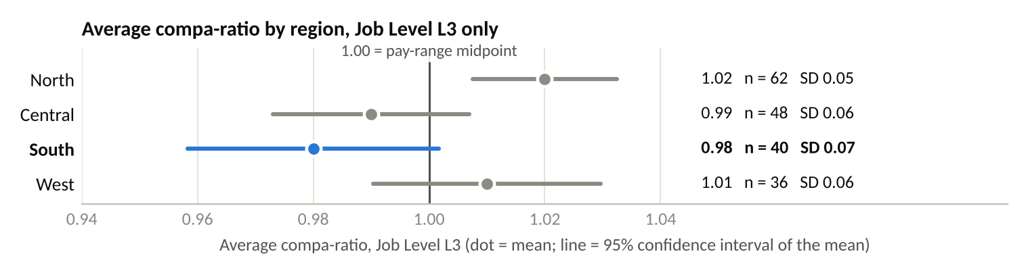
Source: Compensation_Summary (Avg_Compa_Ratio, N_L3_Sample, Compa_Ratio_StDev); PBIX measure [Avg Compa-Ratio]. 95% interval = mean ± 1.96 × SD ÷ √n (computed for this package). Population: L3 sample per region.
Region | Job level (control) | Sample n | Avg compa-ratio | Standard deviation | 95% interval of the mean
North | L3 | 62 | 1.02 | 0.05 | 1.008 – 1.032
Central | L3 | 48 | 0.99 | 0.06 | 0.973 – 1.007
South | L3 | 40 | 0.98 | 0.07 | 0.958 – 1.002
West | L3 | 36 | 1.01 | 0.06 | 0.990 – 1.030
Reading. Comparison control: Region × Job Level L3. South’s 0.98 is the lowest, and its gap of 0.04 to North (1.02) is a real difference at these sample sizes (about 3.1 standard errors; the intervals do not overlap). No uncontrolled organization average is used to judge South; the L3 organization value (1.00) appears only in the CSV roll-up.
Conclusion. Compensation is context, not an established primary explanation. A real gap is not evidence of a cause: the package has no exit reasons or market pay benchmarks linking pay to who left.
7 AI-Assisted Interpretation Validation
Statements from the supplied Copilot summary (Project_ai_assisted_interpretation.docx), each checked against Region_Summary and the source sheets.
# | Statement in the AI-assisted interpretation | Decision | Evidence-based reason
1 | “South is the standout region.” | Accept | South is the outlier on attrition, headcount change, conversion, time-to-fill and backlog (Sections 3–5).
2 | “Voluntary attrition is highest (7.1%).” | Accept | 15 ÷ 210 beginning population = 7.1%, against 1.4–1.8% elsewhere (organization 2.7%). Approved denominator.
3 | “Screened-to-Interview conversion is lowest (55.6%).” | Accept | 75 ÷ 135 = 55.6%, against 75.0–78.6% elsewhere (organization 70.5%).
4 | “Average Time-to-Fill is longest (45 days).” | Accept | 45 days against 30–34 elsewhere (organization 35.7, weighted by requisitions filled).
5 | “Backlog per FTE is roughly double the other regions (6.8).” | Accept | 6.8 against 3.2–3.6 (about 1.9–2.1×). Note: Escalations Ops only, not region-wide.
6 | “Compensation is also the lowest — South’s Avg Compa-Ratio is 0.98…” | Accept | Lowest of the four L3 values (0.98, n = 40); the 0.04 gap to North is real (about 3.1 standard errors), so it is not dismissed as negligible.
7 | “…which explains why people are leaving.” | Reject | Unsupported causal claim. A difference can be real and still explain nothing. No supplied evidence links pay to the leavers: there are no exit reasons, no market benchmarks, and compensation covers an L3 sample, not the people who left. The data are also not consistent with pay alone — Central’s L3 compa-ratio is almost as low (0.99) yet it has the lowest attrition (1.4%).
8 Integrated Workforce Finding
Finding: South is the region needing the most immediate HR follow-up. Its Q2 2026 voluntary attrition is high and concentrated (7.1% vs 2.7% organization), and it is the only region losing headcount.
Role in the finding | Evidence (Q2 2026) | Why it sits here
Primary pattern — concentrated voluntary attrition | Rate 7.1% vs 1.4–1.8% elsewhere; 15 of 27 voluntary leavers (56%); headcount 210 → 205 (Sections 3, 5). | Answers the leadership question directly; measured on the approved denominator; the largest and most concentrated difference.
Secondary pressure — recruiting throughput | Conversion 55.6% vs 70.5%; time-to-fill 45 vs 35.7 days; 18 of 36 requisitions filled (Section 4). | Limits how quickly South can replace leavers. It does not by itself explain why people are leaving.
Secondary pressure — workload | Escalations Ops backlog per FTE 6.8 vs 3.2–3.6 (Section 1 measure). | Operational strain in the focus function. Function-level only, so it cannot be tied to region-wide attrition.
Context — compensation | L3 compa-ratio 0.98 (n = 40) vs 0.99–1.02 (Section 6). | A real but modest gap; no evidence that it explains attrition. Not a primary explanation.
This finding is descriptive. The data show where pressure sits and how the measures line up; they do not show why people left or whether one pressure causes another.
9 Follow-Up Action Comparison
Option | What it involves | Fit to the evidence | Fit to current certainty | Assessment
A. Targeted South voluntary-attrition review (30 days) | Profile the 15 Q2 voluntary leavers (function, level, tenure, team); collect exit reasons; hold stay conversations with Escalations Ops staff; map leavers against the 18 unfilled requisitions. | Strong — aimed squarely at the primary pattern. | Strong — we know where the problem is, not why; this closes that gap at low cost. | Recommended
B. Immediate pay adjustment for South L3 staff | Market uplift for L3 employees in South. | Weak — the compa gap is real but not linked to exits; L3 is a sample, not the leaver group. | Too strong for the evidence; costly and hard to reverse if pay is not the cause. | Not now — revisit only if the review finds pay-related exits.
C. Accelerated backfill hiring | Add recruiter capacity and fast-track the 18 open South requisitions. | Partial — fits the secondary pressures (throughput, backlog). | Moderate, but treats the capacity gap without addressing why people leave; new hires may meet the same conditions. | Not as the lead action — keep existing hiring running during the review.
10 Recommended Action and Owner
Written recommendation to the South regional leader (225 words; also submitted as a separate file)
To: South Regional Leader. Recommendation: commission a targeted review of South's Q2 2026 voluntary attrition before committing to broader action.
South needs the most immediate HR follow-up. Its voluntary attrition was 7.1% in Q2 2026, against 2.7% for the organization and 1.4–1.8% in every other region, and it was the only region to lose headcount (210 to 205). Recruiting is not keeping pace: screened-to-interview conversion is 55.6%, average time-to-fill is 45 days and only 18 of 36 requisitions were filled. Escalations Ops backlog per FTE is 6.8, about double the other regions.
The data show where the pressure is, not why people are leaving. South's L3 compa-ratio (0.98) is the lowest, but no exit-reason or pay-benchmark evidence links it to the leavers, so a pay adjustment now would run ahead of the evidence.
I recommend that the South HR Business Partner, sponsored by you, profile the 15 voluntary leavers by function, level, tenure and team, gather exit reasons, hold stay conversations with Escalations Ops staff, and report findings and options within 30 days. Existing hiring should continue meanwhile. Broader action, including any pay response, should follow only if the review finds a clear, addressable cause, or if South's attrition stays above the organization rate next quarter.
Key assumption: Q2 reflects a continuing pattern rather than a one-off; it is the only quarter with attrition data.

Element | Detail
Affected area | South region (all functions), with Escalations Ops (Support division) as the priority team.
Action | Targeted review of South’s Q2 2026 voluntary leavers, reporting findings and options.
Accountable owner | South HR Business Partner. Sponsor and decision-maker: South regional leader.
Timing | Start now; findings and options to the South regional leader within 30 days; decision on any broader action before the next quarterly workforce review.
Trigger for broader action | The review identifies a clear, addressable cause concentrated in one group (for example, pay-related exits among L3 staff), or South’s voluntary attrition is still above the organization rate in the next quarter’s data.
Material assumption / risk | Assumption: Q2 reflects a continuing pattern rather than a one-off — Q2 is the only quarter with attrition data. Risk: South’s capacity may tighten further while the review runs; existing hiring continues to limit this. No projection here is a certain outcome.
11 Limitation or Next Evidence Need
Material limitation. Attrition, headcount and recruiting data are region-wide, and the only Escalations Ops measure is backlog per FTE. The package therefore cannot show how many of South’s 15 voluntary leavers worked in Escalations Ops, or why any of them left — no exit reasons or market pay benchmarks are supplied.
Next evidence needed. Leaver-level records for South (function, job level, tenure, team, exit reason); Escalations Ops FTE by region, so backlog per FTE can be weighted properly; and next-quarter attrition, to show whether the Q2 pattern persists.
12 Copilot-Use Record
Item | Detail
Copilot-assisted step | First draft of the executive narrative (headline finding, supporting evidence, business implication, next step). This was the only Copilot step; the Section 7 summary was supplied with the brief, not generated for this package.
Tool | Microsoft Copilot app, version 157.0.4341.42. Only synthetic Northwind figures were entered.
Overall decision | Revise. Kept the four-part structure, the verified attrition and headcount statements, and the caveat that the data do not show why people left. Changed scope, the primary/secondary split, the compensation conclusion, the action, owner and timing. The revised text is the Executive summary on page 1.
Exact prompt (verbatim)
Context: I am an HR analyst at Northwind Health Group preparing a quarterly executive HR insight package. All data below is synthetic.
Audience: the regional leadership team and the South regional leader. They are non-technical, short on time, and need a decision.
Reporting period: Q2 2026 (current) compared with Q1 2026 (baseline). Function under focus: Escalations Ops (Support division).

Approved metric definitions (use only these):
- Voluntary attrition rate = Q2 voluntary separations ÷ beginning-of-quarter population. It is a quarterly rate; do not annualise it.
- Screened-to-interview conversion = candidates interviewed ÷ candidates screened. This is not the requisition fill rate.
- Average time-to-fill = mean days from requisition open to fill, for requisitions filled in Q2.
- Average compa-ratio = mean compa-ratio for Job Level L3 within each region (sample sizes 36–62).
- Backlog per FTE = Q2 average backlog ÷ FTE, Escalations Ops only. The Organization value is an unweighted mean of the four regions, not a true organization rate.

Evidence in scope (Q2 2026):
Measure | North | Central | South | West | Organization
Q1 end headcount | 340 | 280 | 210 | 170 | 1,000
Q2 end headcount | 345 | 285 | 205 | 172 | 1,007
Headcount change | +5 | +5 | -5 | +2 | +7
Voluntary leavers | 5 | 4 | 15 | 3 | 27
Voluntary attrition rate | 1.5% | 1.4% | 7.1% | 1.8% | 2.7%
Requisitions open / filled | 28 / 21 | 24 / 17 | 36 / 18 | 16 / 11 | 104 / 67
Screened-to-interview conversion | 78.6% | 75.0% | 55.6% | 75.0% | 70.5%
Average time-to-fill (days) | 32 | 34 | 45 | 30 | 35.7
Average compa-ratio, L3 (sample n) | 1.02 (62) | 0.99 (48) | 0.98 (40) | 1.01 (36) | 1.00 (186)
Backlog per FTE (Escalations Ops) | 3.2 | 3.6 | 6.8 | 3.4 | 4.25 (unweighted mean)

Requested output: a draft executive narrative of 120–150 words in four labelled parts: Headline finding, Supporting evidence, Business implication, Next step. The next step should be one action with a suggested owner and timing.

Constraints:
- Use only the numbers above. Do not calculate new figures or average the regional rates.
- Describe patterns only. Do not say or imply that pay, backlog or recruiting causes or explains attrition; this data cannot show why people left.
- Separate the primary pattern from secondary pressures and context.
- Match the strength of the action to the strength of the evidence.
- Do not present any projection as a certain outcome.
- Use plain English and no jargon.
Copilot output (verbatim)
Headline finding
South Escalations Ops stands out from the other regions in Q2. Voluntary attrition was 7.1% in South, compared with 1.4% to 1.8% in the other regions. South also ended the quarter with a headcount decrease of 5, while the other regions recorded small increases.

Supporting evidence
The primary pattern is the higher voluntary attrition rate in South (7.1%) and 15 voluntary leavers. As context, South also had the largest hiring workload, with 36 open requisitions and 18 filled, the lowest screened-to-interview conversion rate (55.6%), the longest average time-to-fill (45 days), and the highest backlog per FTE (6.8). The average L3 compa-ratio in South was 0.98.

Business implication
The clearest signal is that South differs materially from the other regions on attrition and headcount movement. Other workforce and operational measures also show added pressure in the region, but this data does not identify the reasons employees left.

Next step
Action: Conduct a focused review of Q2 workforce trends in South Escalations Ops, including retention, staffing, and workload indicators, and report findings and options to regional leadership.
Owner: South Regional Leader with HR Business Partner support.
Timing: Complete during Q3 2026.
Verification of each Copilot statement
# | Copilot statement (abridged; full text above) | Decision | Evidence-based reason and change made
1 | “South Escalations Ops stands out from the other regions in Q2.” | Revise | Attrition, headcount and recruiting figures cover the whole South region; only backlog per FTE is Escalations Ops data. Changed to “South” (region).
2 | “Voluntary attrition was 7.1% in South, compared with 1.4% to 1.8%…” | Accept | Attrition_Summary: 15 ÷ 210 = 7.1%; others 1.4–1.8%. Added the organization rate (2.7%).
3 | “…a headcount decrease of 5, while the other regions recorded small increases.” | Accept | Workforce_Movement: 210 → 205; North +5, Central +5, West +2.
4 | “The primary pattern is the higher voluntary attrition rate in South (7.1%) and 15 voluntary leavers.” | Accept | Correct, and consistent with Section 8; 15 of 27 voluntary leavers.
5 | “As context… 36 open requisitions and 18 filled, the lowest… conversion rate (55.6%), the longest… time-to-fill (45 days)…” | Revise | Figures match Recruiting_Summary, but recruiting throughput is a secondary pressure, not just context. 18 of 36 is a fill rate (50.0%), kept separate from conversion.
6 | “…and the highest backlog per FTE (6.8).” | Accept | Matches Business_Context (others 3.2–3.6). Labelled Escalations Ops only.
7 | “The average L3 compa-ratio in South was 0.98.” | Revise | Correct, and Copilot rightly made no causal claim. But it omits that 0.98 is the lowest and the gap to North is real; added the explicit conclusion that compensation is context, not an established explanation.
8 | “…South differs materially from the other regions on attrition and headcount movement.” | Accept | Supported by Sections 3 and 5.
9 | “…but this data does not identify the reasons employees left.” | Accept | Consistent with Section 11. Business implication strengthened with the capacity facts (17 out, 12 in; half of requisitions open).
10 | “Action: Conduct a focused review of Q2 workforce trends in South Escalations Ops…” | Revise | The right level of action (review before broader action), but too broad and limited to Escalations Ops while attrition is region-wide. Refocused on the 15 voluntary leavers across South, with Escalations Ops as the priority team.
11 | “Owner: South Regional Leader with HR Business Partner support.” | Revise | The regional leader receives the recommendation and decides on broader action; the HR follow-up is delivered by the South HR Business Partner as accountable owner, with the leader as sponsor.
12 | “Timing: Complete during Q3 2026.” | Revise | Open-ended for the most immediate follow-up and has no checkpoint. Changed to findings within 30 days, plus a stated trigger for broader action.
AI drafting disclosure. Besides the Copilot step above, Claude (Anthropic’s AI assistant) helped prepare this package: it recomputed the figures and organization roll-ups from the workbook counts, ran the reconciliation checks, drew Exhibits 3–6 in Python, wrote the Copilot prompt and drafted section text. Every figure was checked against the source workbook and the Power BI measures, and the analyst is accountable for the final content.

